Project (Low-Fidelity) Prototype

Group 3, Lab Section B02  
February 26, 2020  
  
Kyle Wilson – V00897204  
Kenil Shah – V00903842  
Jacob Thom – V00892893  
Kelly Hamilton – V00869519  
Spencer Hart – V00895336

## Question 1 response:

The prototypes considered most aligned to the future of this app would be the individual menus for moving, sharing, and “opening in”. The menus that deal with showcasing options are subject to change and manipulation and are simply shown to show possible navigation and relation. These prototypes will be changed in the future to better fit user interaction.

**Sharing Tool**

|  |  |  |
| --- | --- | --- |
| Main page for a file folder | Menu if single object selected and ellipsis is clicked | Menu if multiple objects selected and ellipsis is clicked and ellipsis is clicked |
|  |  |  |
| If “move” is selected | If “share” is selected | If “open in…” is selected |

**A low-fidelity prototype of a mass renaming tool**

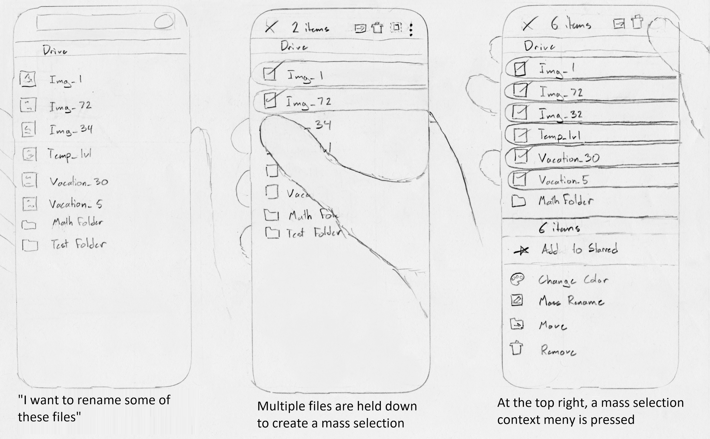

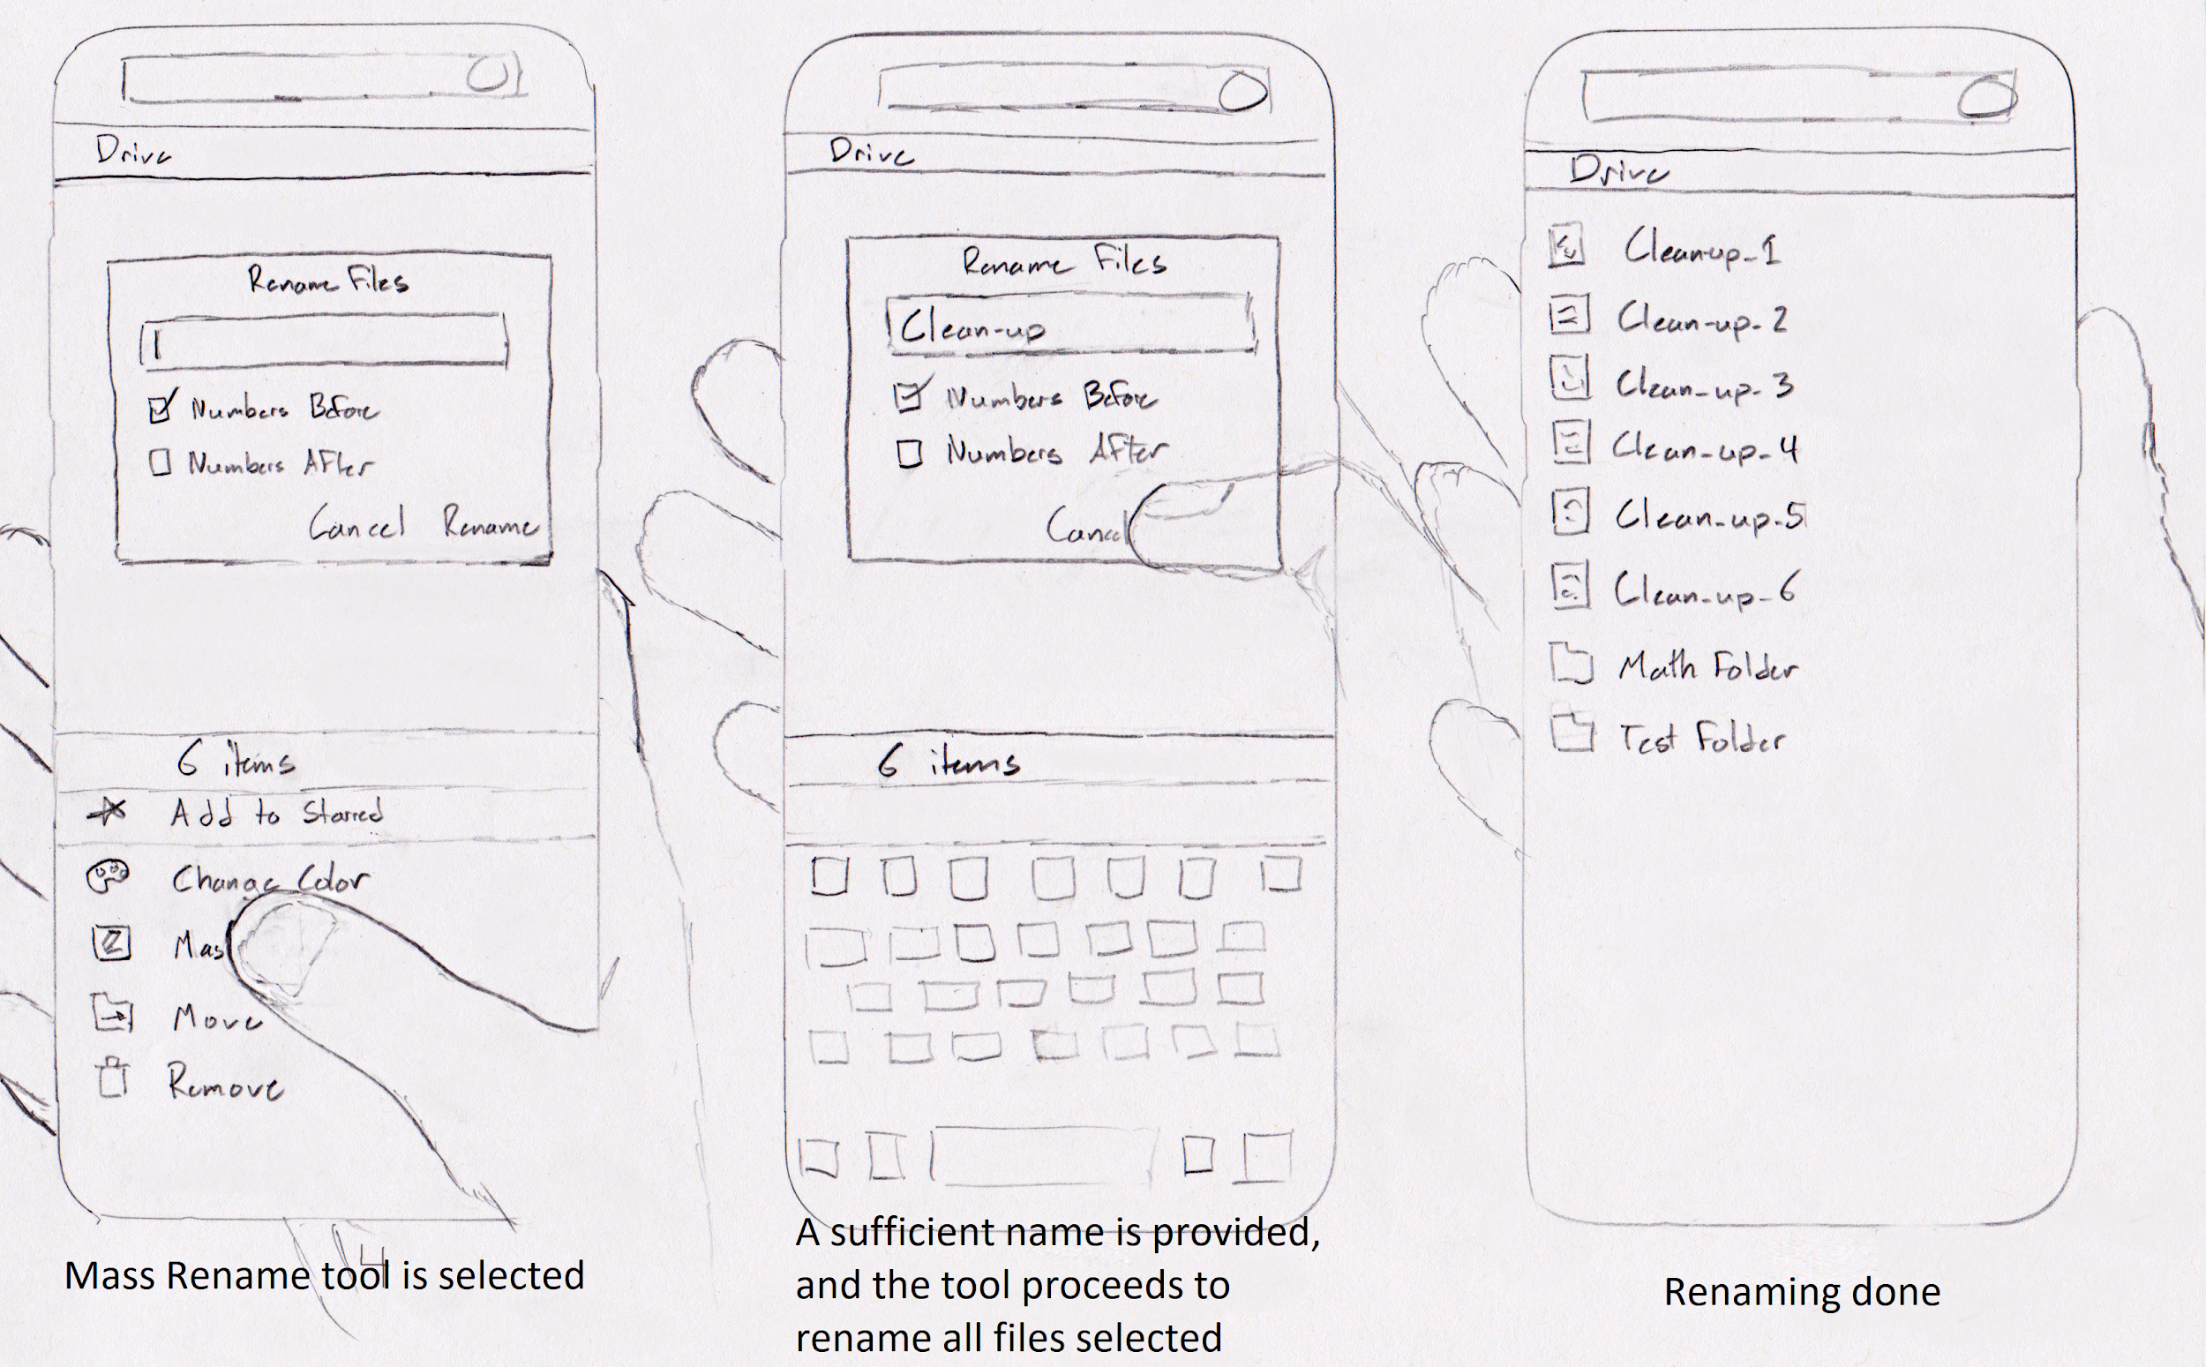

This prototype details an example mass rename tool. This feature is currently lacking within the current iteration of Google Drive. This tool may help with organization for those with countless files of a similar type, such as photographers and office workers. While this prototype is quite detailed in what it wishes to show, as it is a vertical prototype, it lacks a broader scope.

|  |  |  |
| --- | --- | --- |
| If the “create” function is used | If “sort” is selected | List of files |
|  |  |  |
| Multiple select options | Renaming files | Result of renaming |

Create is an example of the options presented to the user when they go to create a new object in their drive. They are presented with the usual options that you would expect, with additional options of Google partnered apps. Sorting is an important part of the app and it is giving you the arrows to sort by newest or oldest as well as all the sorting options you would want. Finally, a higher quality version of the mass rename tool that was talked about previously

**A low-fidelity prototype of sorting by date created**

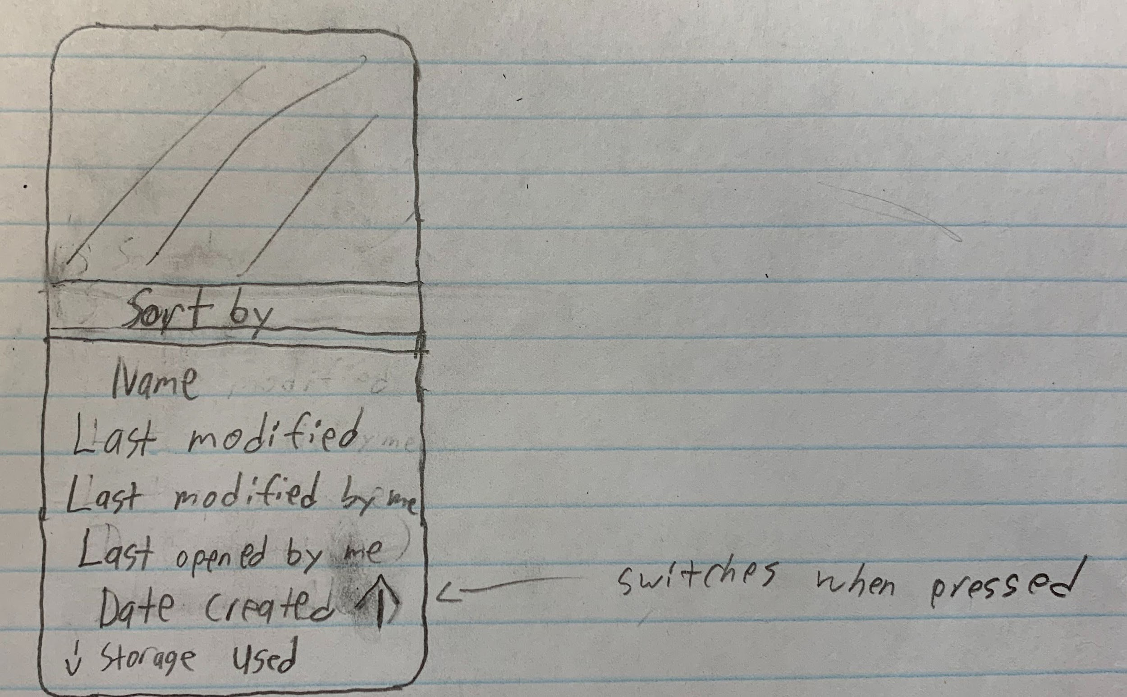

This prototype details an example of an additional sorting field for the Google Drive app. Currently, it lacks the ability to sort by the date that files were created. If already sorted by date created, re-selecting this option would invert the order between ascending and descending, as indicated by the arrow icon direction (up or down). A more polished version of this low-fidelity prototype will likely be included in future iterations of this project as it would be a useful feature that is currently lacking.

**A low-fidelity prototype of a clean tool**

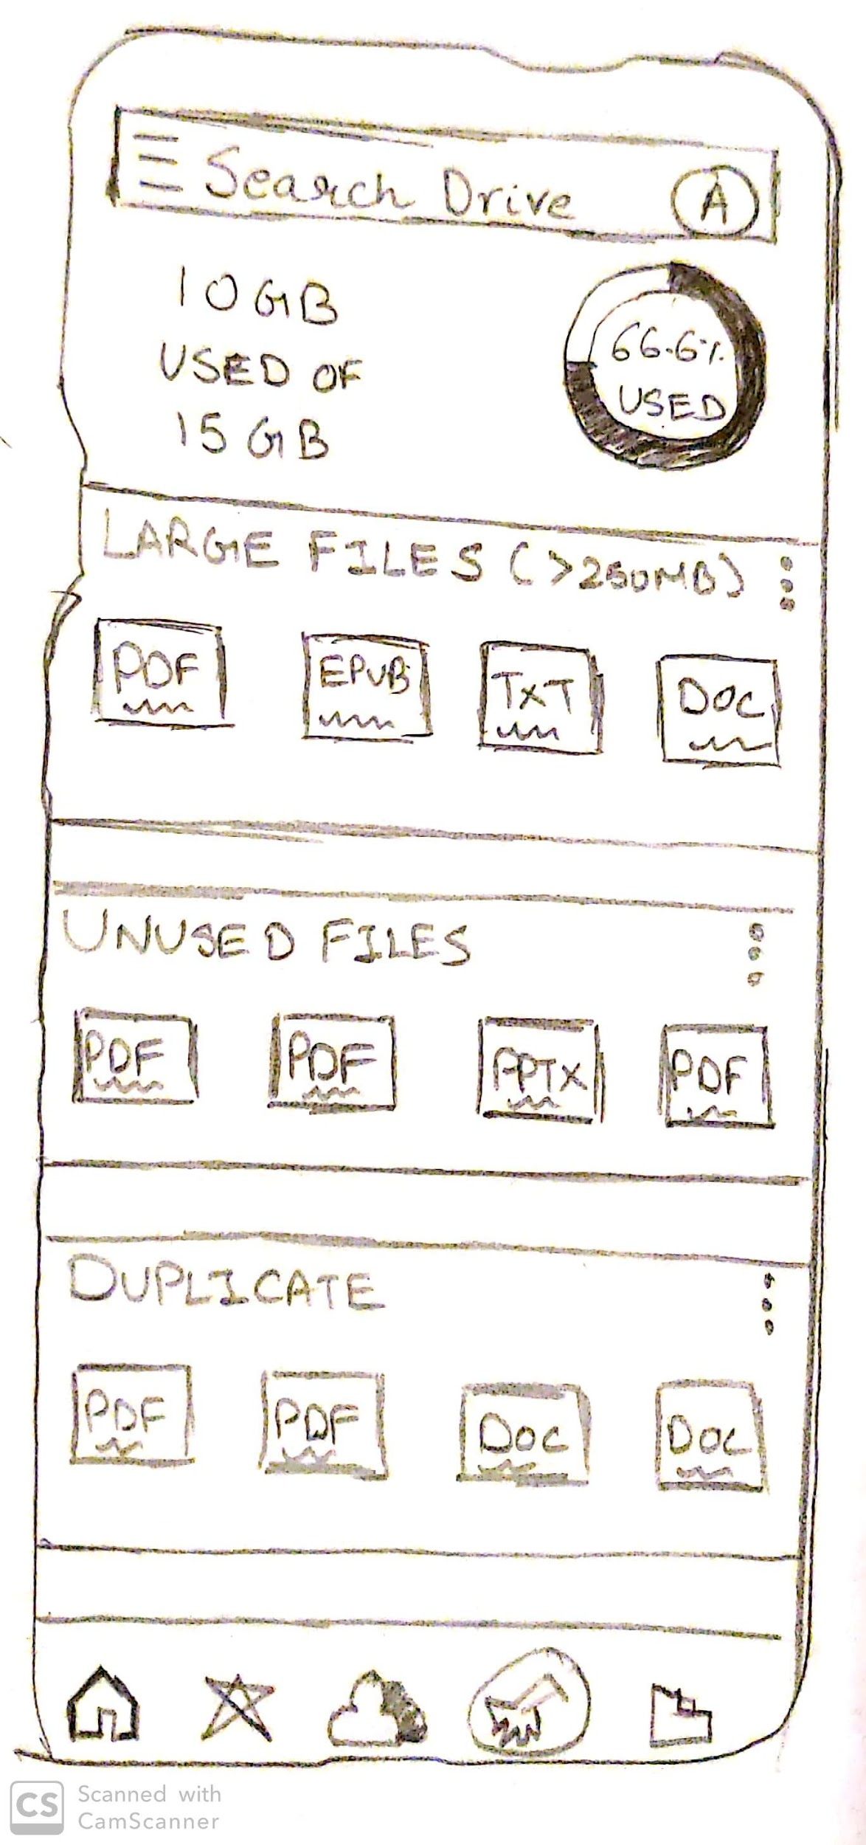

This is a prototype for incorporating a ‘clean’ function to the Google Drive app. Currently, users lack any tools to declutter or clean up their drive, making it a chore to efficiently delete unnecessary files. We would like to go into the functionality of such a tool in further iterations of the prototype.